Power Bi Notes.

1. Open Power Bi and have the two .csv data files from moodle somewhere in your file system (you should know which folder they are in). 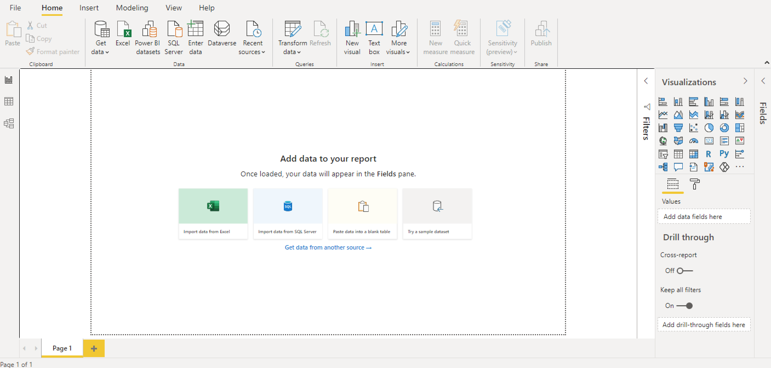
2. Load one data file (I chose temp.csv). You can do this by selecting the “Get data” option from the left of the top ribbon in PowerBI or you can select “Get data from another source” and find your csv file from there. Your data will show up in a table, hit “Load” to load it: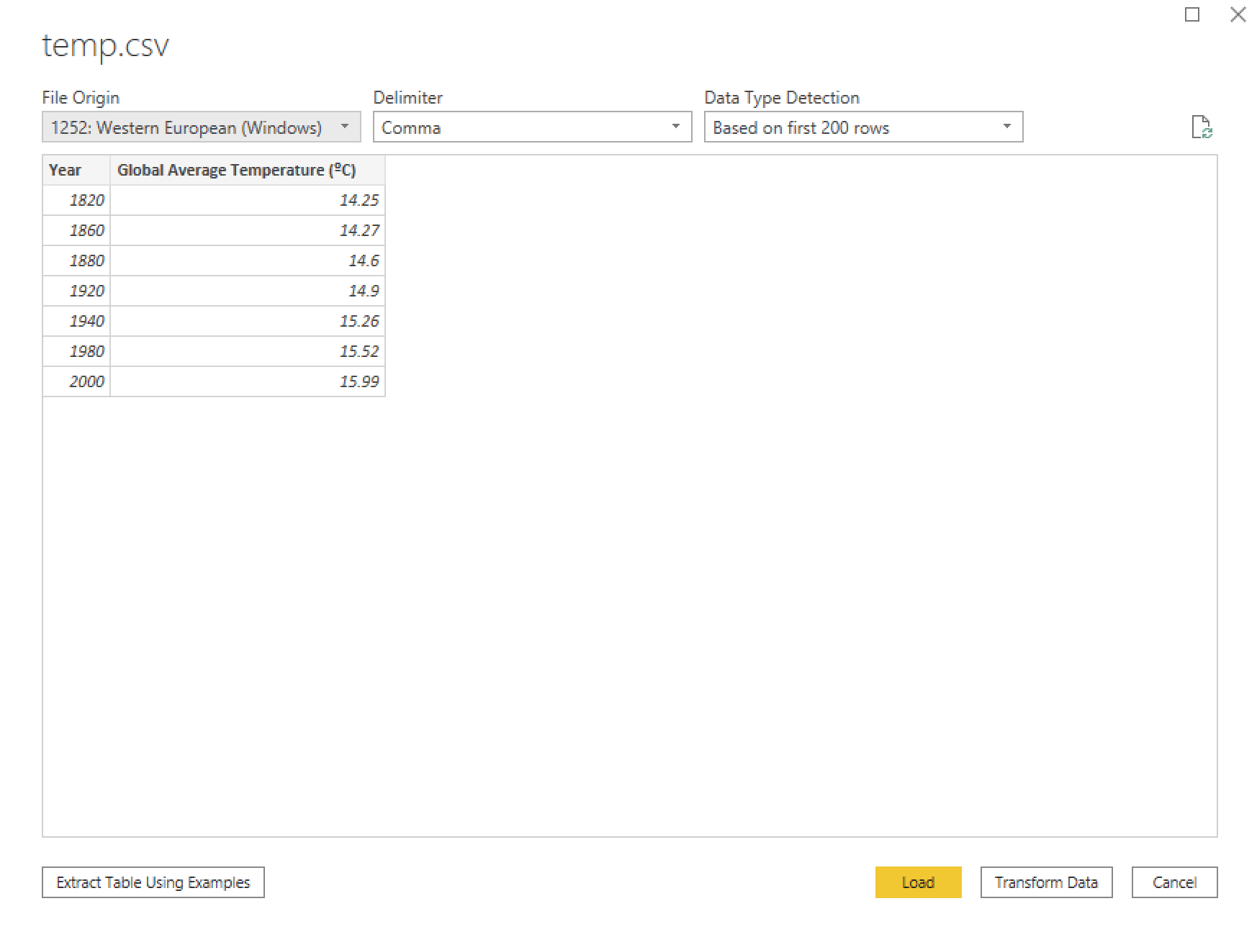
3. Find the three tabs down the left hand side: Report, Data and Model. You’ll currently be in the “Report” section: 
4. Go to Model (the bottom option), Select “Get data” (on the top tool bar ribbon) and load the other file (pirates.csv).
5. PowerBI will automagically find the connection (“Year”) and form a *relationship* between your two tables.
6. Now you want to plot the Pirates vs Temperatures line graph or scatter plot. Go to the “Report” tab.
7. You want to add a new visual (that’s a graph), so go to the “Visualizations” section and select a “Scatter Plot” (hover over each of the icons in turn to see their names. Once you select the scatter plot, you’ll see places to add your X-axis and your Y-axis. X is across (“a cross” or horizontal). From our example graph, “Pirates” go on the X-axis and Temperatures on the Y-axis. You can click and drag these fields directly from the “fields” section and PowerBI will plot your graph. 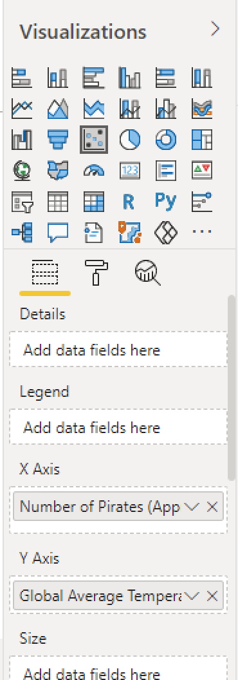
8. **Why is there only one point on my graph?** Once the fields are in place, make sure you select “Don’t summarize” from the drop down menu. The default is “Sum” which gives you only one value for each field (the sum). Once you’ve done this, all your points should appear and you should have a graph: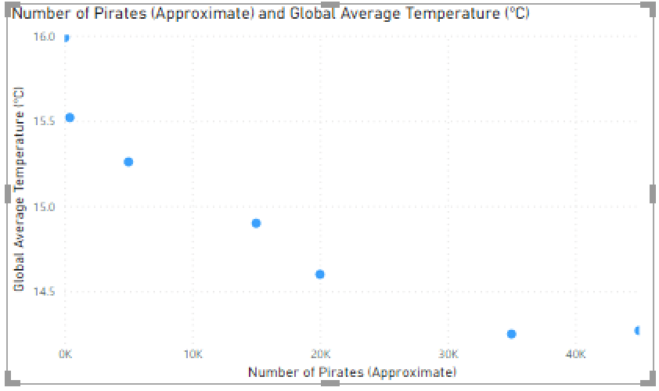
9. Now, still in the “Visualizations” section, move from the “Details” tab to the “Format” tab. (the yellow-underlined paint-roller-thing in the next image). Under this tab you can select X axis and scroll down to the option to invert it.
10. 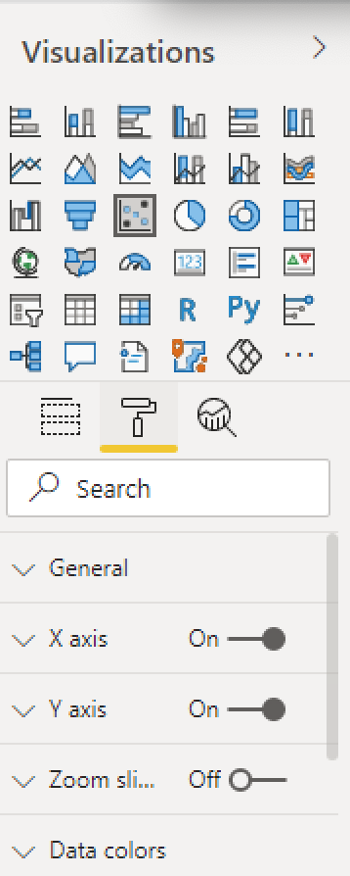
11. Bonus extras: try to wilfully make your graph misleading by equalising the distance between each of the “pirate” points (either by making them categorical rather than numbers or some other way). If you can’t manage it with a scatter plot, try doing it with a line graph like in the example on Moodle (or the line graph below).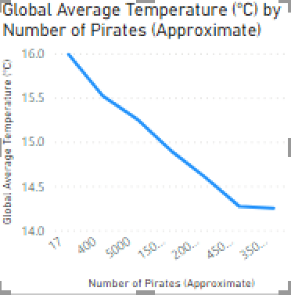
12. The last task is to plot the “two line” graph. For this, you’ll need a new visualisation and you’ll need to make it a line graph. In the “Visualization” tab, in the “Fields” section, click and drag “years” for the axis and then click and drag the “Number of Pirates” and “Global Average Temperatures” fields into “Values” and “Secondary values”. This should plot the graph. You can now format it as you wish.
13. Bonus: What happens if you put both fields in the “Values” box? How does the graph change? Can you change the axes (X-, Y- and secondary Y-) using the “Format” tab?
14. Your final PowerBI report might look something like this: 